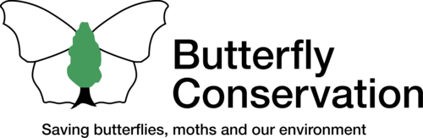
JOB APPLICANT PRIVACY NOTICE

Butterfly Conservation collects a range of data about you during a recruitment process which will include:

- Your name, contact details and address;

- Details of your skills, qualifications, experience and employment history;

- Information regarding your right to work in the UK; and

- Details regarding your current level of remuneration and any work benefit entitlements.

This information will be collected from your application form and/or covering email or letter on submission to us, plus from your examination certificates, passport, driving licence or other identity documents provided. We may also collect personal data about you from third parties, such as references obtained from former employers, background checks or criminal record checks, as applicable.

This data will be stored in an electronic format (including email) on our internal IT systems and also in paper form within our HR Department. Your information may be shared internally for recruitment purposes with our directors, HR and IT teams strictly for decision making purposes. We do not share your data with any third parties.

We need to process your data to take the necessary steps prior to entering into any contract with you. We may also need to process your data if we agree to enter into a contract with you. We have a legitimate interest in processing your data during a recruitment process to ensure that we make and keep records of this process. These records allow us to manage the process effectively, assess a candidate’s suitability for employment and decide whom to offer roles to. We may also, from time to time, need to process data from job applicants to respond to and defend against legal claims.

As a data subject, you have a number of rights including access to your data on request, to stop us processing your data on demand, to ask us to delete your data on demand or to change any incorrect or incomplete data we hold on you. If you believe that we have not complied with your rights, you can complain to the Information Commissioner.

Butterfly Conservation will not transfer your data outside of the European Economic Area. We will protect your data internally through internal controls and policies to ensure that your data is not lost, accidently destroyed, misused or disclosed, and is not accessed by our employees except in the proper performance of their duties.

We will keep your personal data in this regard for a maximum of six months unless you withdraw your consent during this timescale. Our recruitment processes are not based on automated decision making and you are under no statutory or contractual obligation to provide your data to us. If you elect not to do so however, we will not be able to process your application properly, if at all.

